**Copy data & Paste it to another Sheet**

**Step 1:** Firstly we need to Create two sheet i.e. one is Source Sheet & another one is Destination sheet, where we have to paste data. In this example we have two sheet with the name ‘source’ & ‘Destination’.

Step 2: In this step, have to copy the Spreadsheet ID of the source and the Destination Sheet. We can easily extract from the link of spreadsheet as shown in the below figure.



**Step 2:** In this step we simply need to open the App Script by clicking on Extensions and then Apps Script in the Menu bar of Spreadsheet.

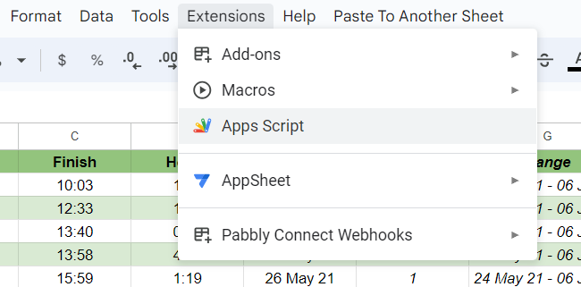

**Step 3:** After opening the Apps Script, paste those links i.e. source and destination link in the line no. 11 and 13 as shown below.

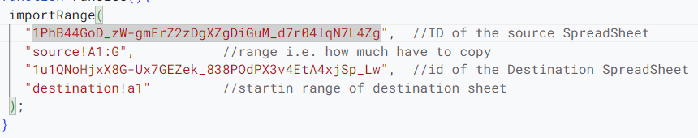

**Step 4:** Now in the line 12 set the range of source spreadsheet like how much data you want to copy and Similarly for the Destination sheet means where you want to paste your copied data i.e. stating range.

**Step 5:** After setting this Save the file with ctrl + S.

**Step 6:** Now simply click on the ‘Paste to Another Sheet’ and then ‘Paste’ in the menu bar of Spreadsheet and you got the copied data into the destination sheet.



Example:-

In the example we have two sheet i.e. ‘source’ and ‘Destination’ sheets. The source sheet is, where we data that we want to copy and the Destination sheet is, where we want paste the copied data.

Source Sheet

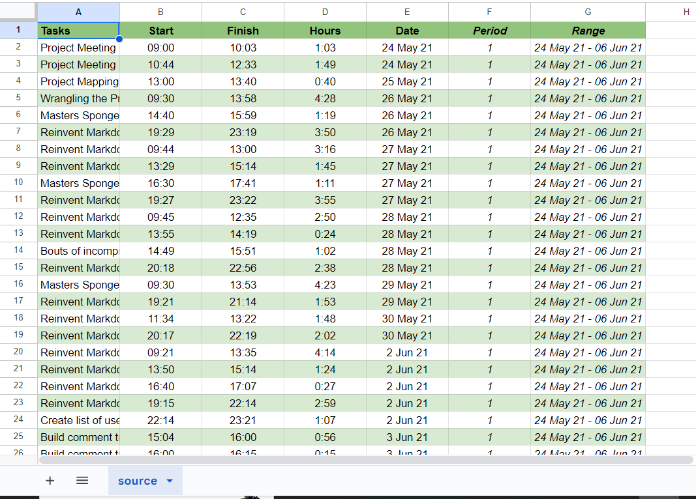

Destination Sheet

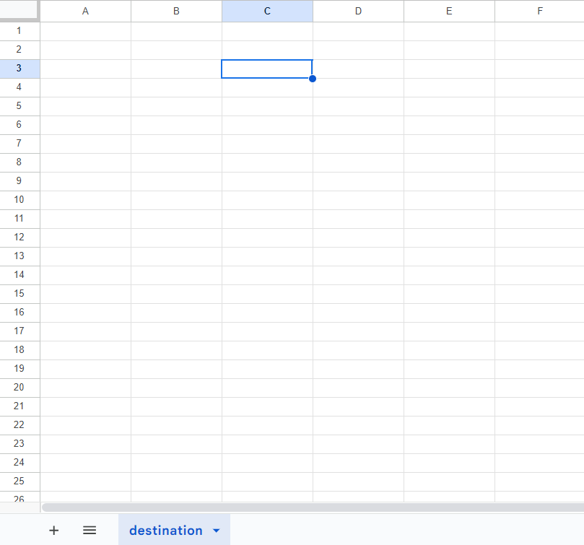

After opening both the sheet then set or change the spreadsheet id as mentioned before in the various steps.

Now just simply click on Paste To Another Sheet and then Paste from the menu bar in the source sheet.



Finally you will be able to get the data in the destination sheet as shown below.

